Day 21 - 24th july 2025

SOLID

Liskov Substitution Principle 👍

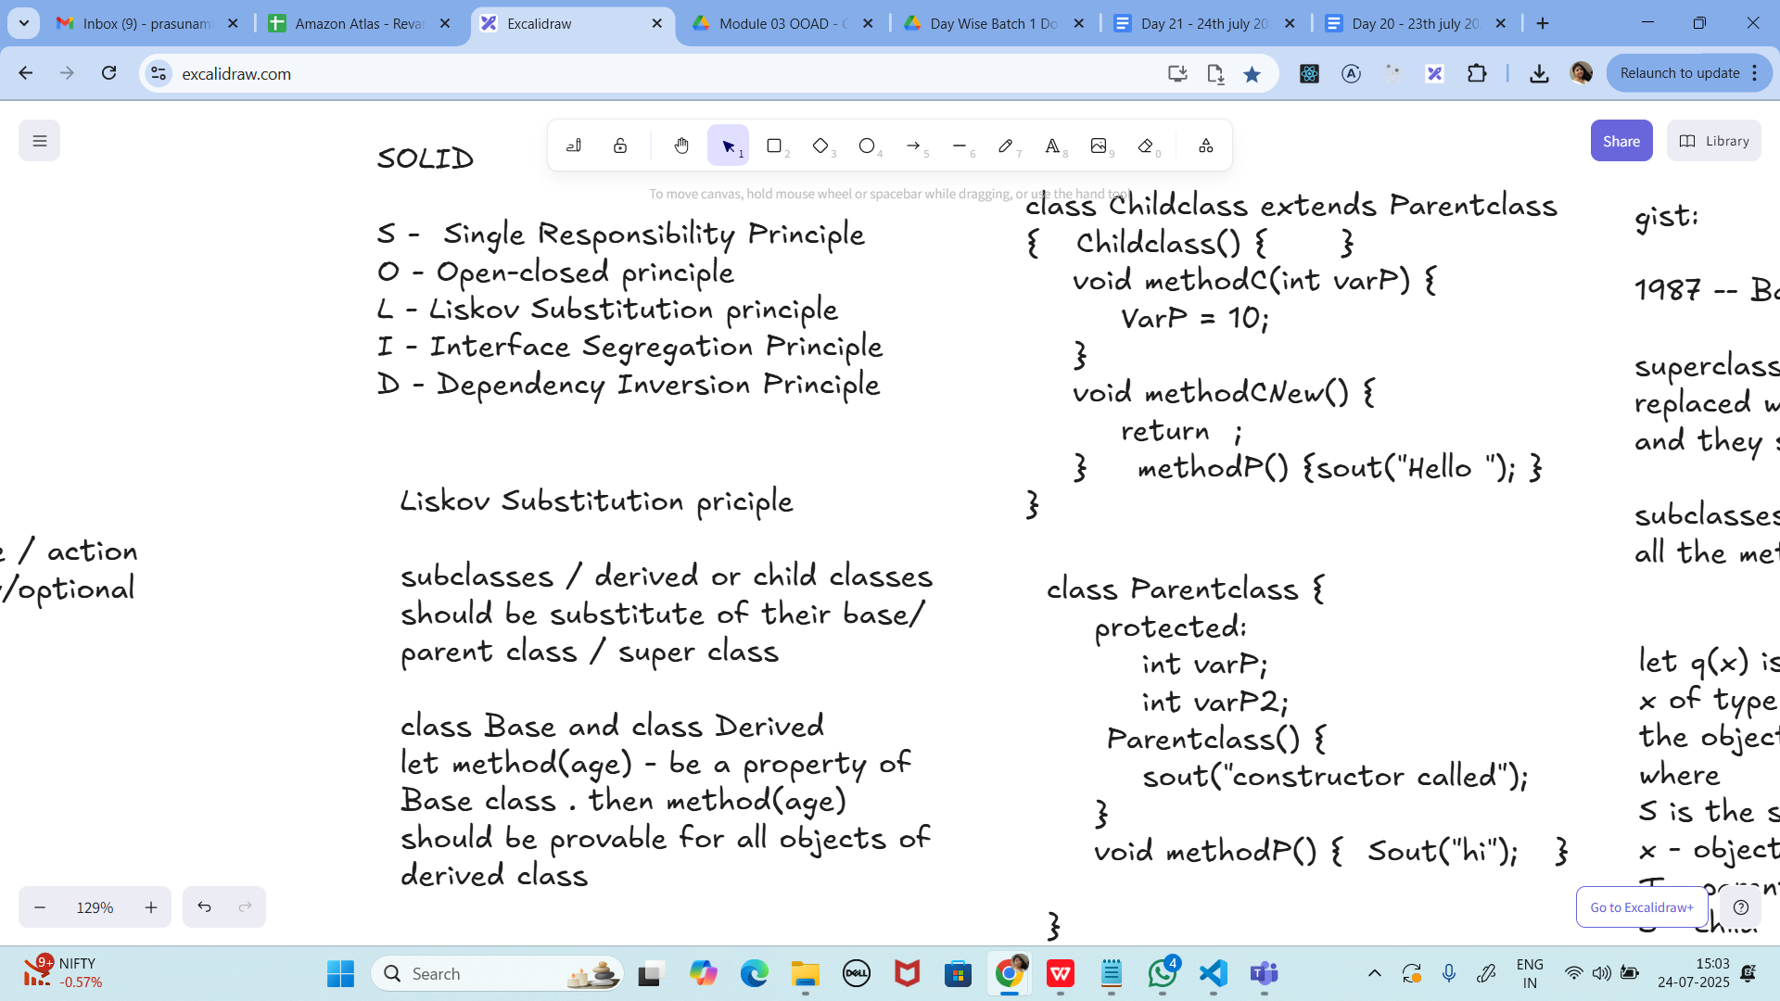

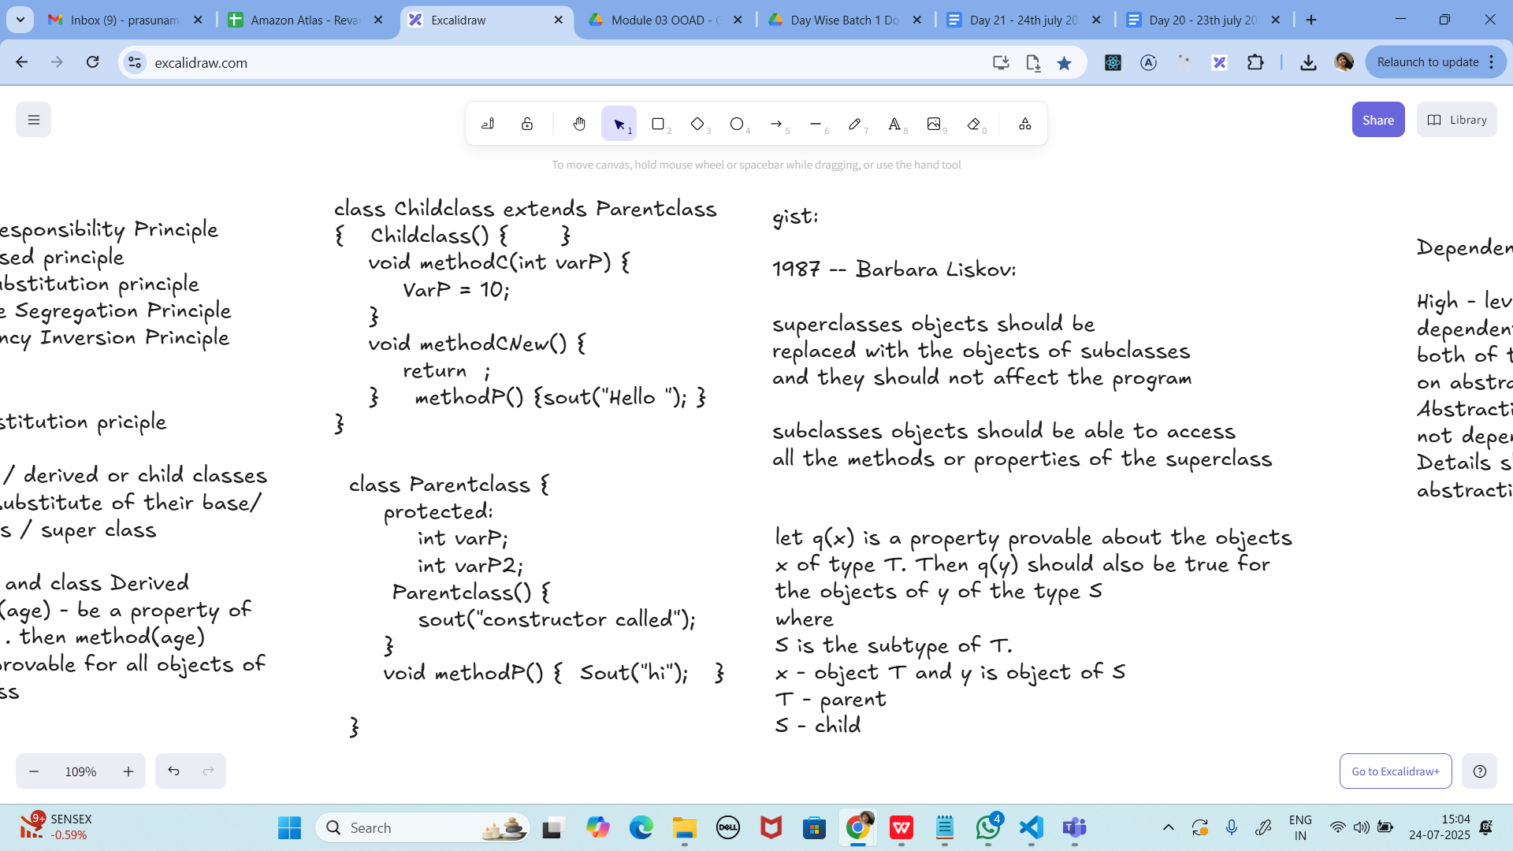

Task 01:
class Animal {
void sound() {
sout(" sounds of different animals");
}
}
class Cat extends Animal{
@Override
void sound() {
sout(" Meow is the sound of cat");
}
}
class Main{
psvm(String[] args) {
Animal obj = new Cat();
obj.sound(); //Meow is the sound of cat
}
}

import java.util.*;

class Animal {
void sound() {
System.out.println(" sounds of different animals");
}
}

class Cat extends Animal {
@Override
void sound() {
System.out.println(" Meow is the sound of cat");
}
}

class Task02 {
// Utility method to print any list
static void printList(List<?> list) {
for (Object element : list) {
System.out.println(element);
}
}

public static void main(String[] args) {
Animal obj = new Cat();
obj.sound(); // Meow is the sound of cat

List<Cat> clist = new ArrayList<>();
clist.add(new Cat());

printList(clist); // Will print something like: Cat@15db9742
}
}

issue with Substitution and Generics

Java Generics -- it has introduced a challenge - substitution principle...

is cat a subtype of Animal, List<cat> is not a subtype of List<Animal>

List<Cat> Cobj = new ArrayList<>();
List<Animal> Aobj = Cobj; ===// this will give you a wildcard ,

wildcards:

1. unbounded Wildcard
? ===> any data type if you want to use you can use ?

2. Bounded Wildcards with an upper bound (? extends Type)

===> yopu will use it when you need to accept a type and its own subtypes

3. Bounded Wildcards with an lower bound (? super Type)
===> you will use when ypou need accept a type and its super types

Unbounded wildcards:
Task 02:
they are useful when the code does not depends on the actual type parmeter

void printList(List<?> list) {
for(Object element: list) {
sout (element);
}
}

List<Cat> clist = new ArrayList<>();
clist.add(new Cat());
printList(clist); //

import java.util.*;

class Animal {
void sound() {
System.out.println(" sounds of different animals");
}
}

class Cat extends Animal {
@Override
void sound() {
System.out.println(" Meow is the sound of cat");
}
}

class Task02 {
// Utility method to print any list
static void printList(List<?> list) {
for (Object element : list) {
System.out.println(element);
}
}

public static void main(String[] args) {
Animal obj = new Cat();
obj.sound(); // Meow is the sound of cat

List<Cat> clist = new ArrayList<>();
clist.add(new Cat());

printList(clist);
}
}

---------------------------
Task 03:

Upper Bounded Wildcards

void animalSound(List<? extends Animal> animalList) {
for(Animal elements : animalList
elements.sound();
}
}
List<Cat> cats = new ArrayList<>();
cats.add(new Cat());
animalSound(cats); //meow

import java.util.*;

// Base class
class Animal {
void sound() {
System.out.println("sounds of different animals");
}
}

// Derived class
class Cat extends Animal {
@Override
void sound() {
System.out.println("Meow is the sound of cat");
}
}

public class Task03 {

// Method that accepts List of Animal or any of its subclasses
public static void animalSound(List<? extends Animal> animalList) {
for (Animal element : animalList) {
element.sound();
}
}

public static void main(String[] args) {
// Create list of Cats
List<Cat> cats = new ArrayList<>();
cats.add(new Cat());

// Call method with upper bounded wildcard
animalSound(cats); // Output: Meow is the sound of cat
}
}

----------------------------
Task 04:

lower Bounded Wildcards

void addAcat(List<? super Cat> cats) {
cats.add(new Cat());
}
List<Animal> animals = new ArrayList<>();
addAcat(animals); //

import java.util.*;

class Animal {
void sound() {
System.out.println(" sounds of different animals");
}
}

class Cat extends Animal {
@Override
void sound() {
System.out.println(" Meow is the sound of cat");
}
}

class Task04 {
// Lower-bounded wildcard method: can add Cat or subclass into list of Cat or superclass
static void addAcat(List<? super Cat> cats) {
cats.add(new Cat());
}

public static void main(String[] args) {
Animal obj = new Cat();
obj.sound(); // Meow is the sound of cat

// Use lower bounded wildcard with Animal list
List<Animal> animals = new ArrayList<>();
addAcat(animals); // Adds Cat to animals list

// Verify contents
for (Animal animal : animals) {
animal.sound(); // Meow is the sound of cat
}
}
}

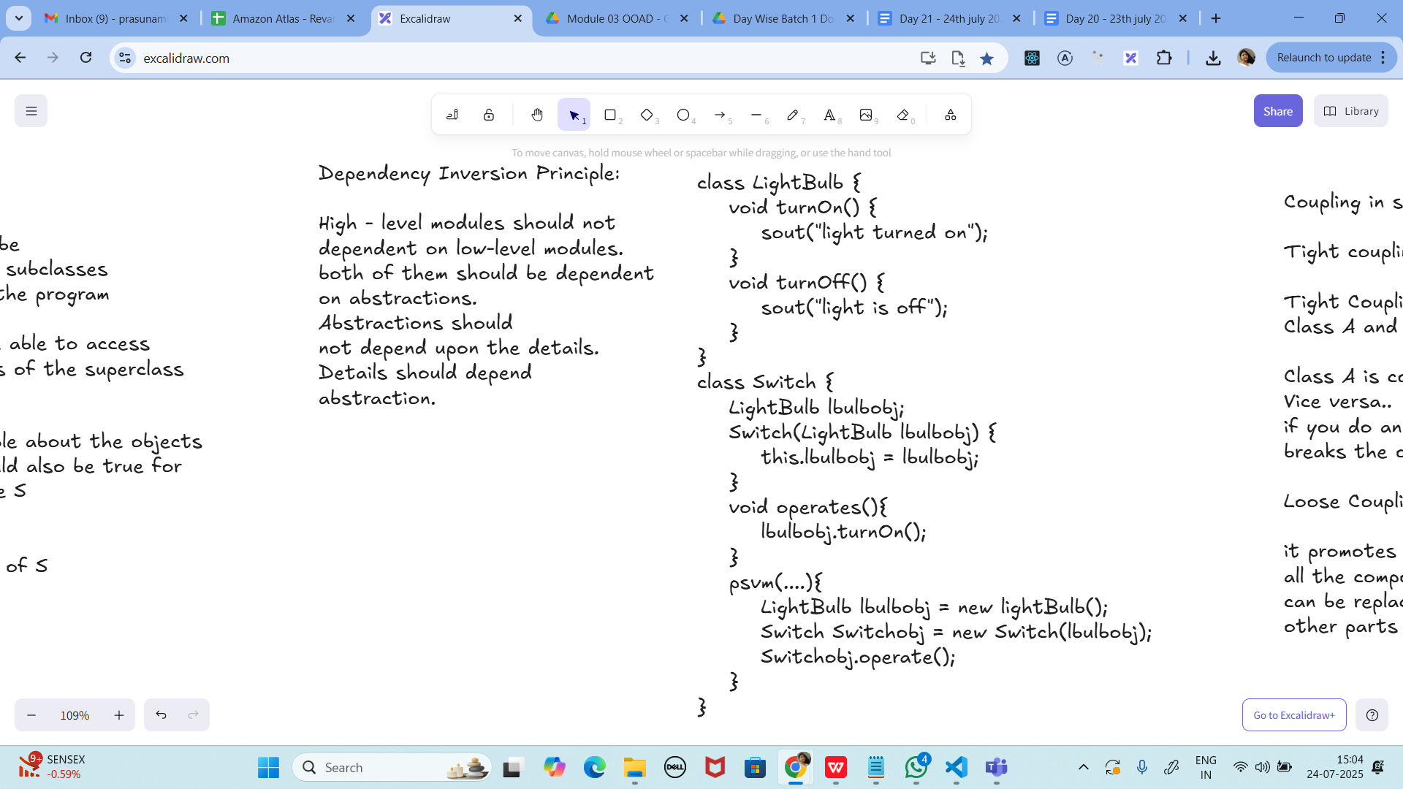

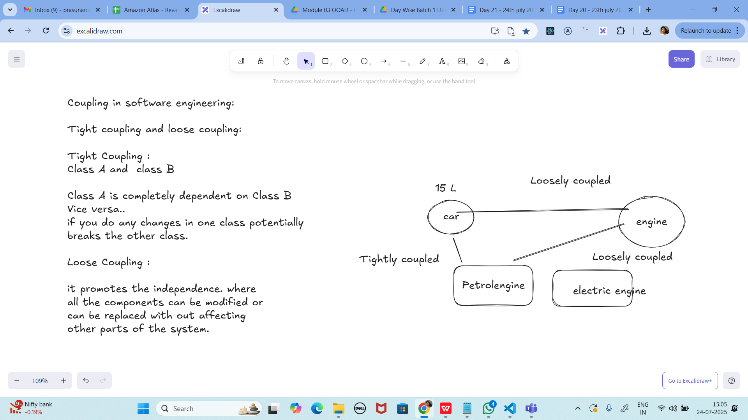

Task 05:

// tight coupling

class Student {
public int roll_no = 10;
//private int roll_no = 10; // this code breaks...
public int getRoll() {
sout("getRoll method");
return roll_no;
}
public void setRoll(int roll) {
if(!(roll > 100)
roll_no = roll;
}
}
class Tight_coupling {
psvm(String....) {
Student sobj = new Student();
sobj.roll_no = 10; // we are not following the rule of Student class roll no > 100..
//sobj.roll_no = 110;
sout("the roll no of student is "+ sobj.roll_no); // 110 // private - error //10
}
}

class Student {
public int roll_no = 10;
//private int roll_no = 10;
public int getRoll() {
System.out.println("getRoll method");
return roll_no;
}
public void setRoll(int roll) {
if(!(roll > 100))
roll_no = roll;
}
}
class Tight_coupling {
public static void main(String[] args) {

Student sobj = new Student();
sobj.roll_no = 10;
//sobj.roll_no = 110;
System.out.println("the roll no of student is "+ sobj.roll_no); // 110
}
}
Task 06:

// loose coupling

class Student {
private int roll_no = 0;
public int getRoll() {
sout("getRoll method");
return roll_no;
}
public void setRoll(int roll) {
if(!(roll > 100)
roll_no = roll;
}
}
class Loose_coupling {
psvm(String....) {
Student sobj = new Student();// Person pobj = new Student(); // person got a bonus
sobj.setRoll(10);
sout("the roll no of student is "+ sobj.getroll();
}
}

class Student {
private int roll_no = 0;

public int getRoll() {
System.out.println("getRoll method");
return roll_no;
}

public void setRoll(int roll) {
if (!(roll > 100)) { // condition properly closed
roll_no = roll;
}
}
}

public class Task06_LooseCoupling {
public static void main(String[] args) {
Student sobj = new Student(); // Person pobj = new Student(); // would work if Student extends Person
sobj.setRoll(10);
System.out.println("The roll no of student is " + sobj.getRoll());
}
}

Task 07:

//DIP violating

class LightBulb {
void turnOn() {
sout("light turned on");
}
void turnOff() {
sout("light is off");
}
}
class Switch { // switch class directly depends on the lightbulb class ---- DIP violating
LightBulb lbulbobj;
Switch(LightBulb lbulbobj) {
this.lbulbobj = lbulbobj;
}
void operates(){
lbulbobj.turnOn();
}
psvm(....){
LightBulb lbulbobj = new lightBulb();
Switch Switchobj = new Switch(lbulbobj);
Switchobj.operate();
}
}

// DIP Violating Example

class LightBulb {
void turnOn() {
System.out.println("Light turned on");
}

void turnOff() {
System.out.println("Light is off");
}
}

class Switch { // Switch class directly depends on the LightBulb class (DIP violation)
LightBulb lbulbobj;

Switch(LightBulb lbulbobj) {
this.lbulbobj = lbulbobj;
}

void operate() {
lbulbobj.turnOn(); // tightly coupled to LightBulb
}

public static void main(String[] args) {
LightBulb lbulbobj = new LightBulb();
Switch switchObj = new Switch(lbulbobj);
switchObj.operate();
}
}

Task 08:

DIP implementation:

interface SwitchOnOff {
void turnOn();
void turnOff(); // void remoteControl();// void alexaVoiceControl();
}
class LightBulb {
void turnOn() {
sout("light turned on");
}
void turnOff() {
sout("light is off");
}
} // or class fan, class inverter, class washing machine...(in future remote for washing machine
// i can extend without modification..
class Switch { // switch is depending on switchonoff class not on light bulb..
SwitchOnOff device;
void Switch(SwitchOnOff device) {
this.device = device;
}
void operates() {
device.turnOn();
}
}
class DIP {
psvm(....){
SwitchOnOff lbulbobj = new LightBulb();
Switch lightswitch = new Switch(lbulbobj);
lightswitch.operate();
}
}

// DIP Implementation Example

interface SwitchOnOff {
void turnOn();
void turnOff();
}

// LightBulb implements abstraction, not tied directly to Switch
class LEDLight implements SwitchOnOff {
public void turnOn() {
System.out.println("Light turned on");
}

public void turnOff() {
System.out.println("Light is off");
}
}

// Future devices can also implement SwitchOnOff without changing Switch class
class Fan implements SwitchOnOff {
public void turnOn() {
System.out.println("Fan started spinning");
}

public void turnOff() {
System.out.println("Fan stopped");
}
}

// Switch depends on abstraction, not on concrete class
class DeviceSwitch {
private SwitchOnOff device;

DeviceSwitch(SwitchOnOff device) { // constructor, not void method
this.device = device;
}

void operate() {
device.turnOn();
}
}

public class Task08 {
public static void main(String[] args) {
// Using LightBulb
SwitchOnOff bulb = new LEDLight();
DeviceSwitch lightSwitch = new DeviceSwitch(bulb);
lightSwitch.operate();

// Using Fan (no modification in Switch class)
SwitchOnOff fan = new Fan();
DeviceSwitch fanSwitch = new DeviceSwitch(fan);
fanSwitch.operate();
}
}

Association, Composition, Aggregation, Inheritance
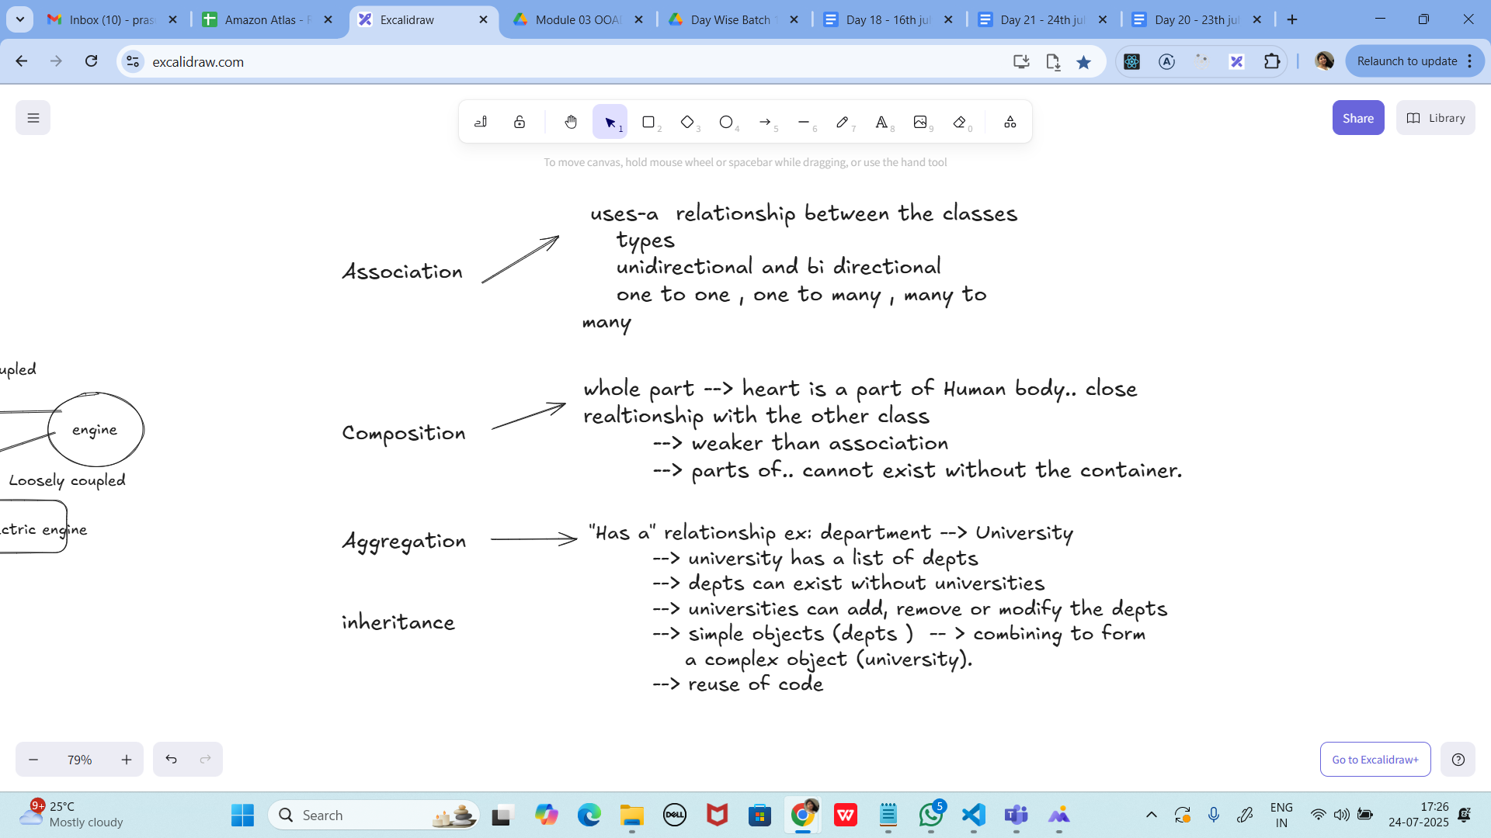

Task 09:

Why should we choose Composition over Inheritance?

Loose coupling

Flexibility

Better encapsulation

When designing object-oriented systems, a common design choice is whether to use inheritance (“is-a” relationship) or composition (“has-a” relationship). Although inheritance has its place, composition is generally preferred because it leads to cleaner, more maintainable, and flexible code.

1. Loose Coupling
Inheritance creates a tight coupling between the parent and child classes. Any change in the parent can ripple down and break child classes, making the system fragile.
Composition, on the other hand, allows classes to interact through interfaces or references, leading to loose coupling. This ensures that one class can change without directly impacting another.
Example:
Instead of making Car inherit from Engine, we design Car to have an Engine. Now, if we replace the Engine with an ElectricEngine, the Car class doesn’t need modification.

2. Flexibility
Inheritance is static. Once a class extends another, it cannot change its parent at runtime.
Composition is dynamic. Objects can be composed of different components at runtime, allowing behavior changes without altering class hierarchies.
Example:
A PaymentService can switch between CreditCardPayment, UPIPayment, or PayPalPayment objects dynamically, simply by composing with a different payment strategy.

3. Better Encapsulation
Inheritance often exposes methods and properties that may not make sense for the subclass, which breaks encapsulation.
Composition allows a class to only expose what is necessary, keeping the implementation details hidden and the class focused.
Example:
If Bird inherits from Animal, it may inherit methods like walk(), even though not all birds walk well. With composition, we can design Bird to only contain relevant behaviors (e.g., FlyBehavior, SingBehavior).

Conclusion
- Inheritance should be used only when there is a clear “is-a” relationship.
- Composition should be preferred when we want:
  - Loose coupling
  - Flexibility
  - Better encapsulation
In practice, most modern design principles (SOLID, Strategy Pattern, Dependency Injection) encourage “favor composition over inheritance” to build more maintainable and scalable software.

UML representation

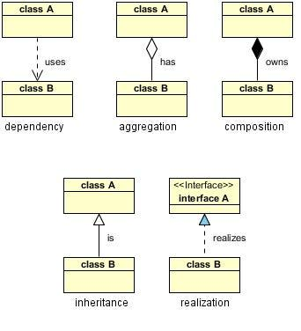

Info box:

=============================================================

https://excalidraw.com/#json=_N42kljaUBYMEJbzBEG_Z,gBOJnMKaULoQxKebr7Hzsw

6. Explain the different types of relationships in UML (association, aggregation, composition, inheritance)
- Association : A relationship between two classes that indicates a connection or link between their objects.
- Aggregation : A special type of association that represents a "has-a" or "part-of" relationship, where one class is a part of another class, but they have separate lifetimes.
- Composition : A stronger form of aggregation, where the contained object's lifecycle is dependent on the container object.
- Inheritance : A relationship where one class (subclass) inherits the structure and behavior of another class (superclass), enabling code reuse and specialization.

================================================================================================================================================

